Win Rates for mancala game:

For testing with Random player with (Minimax and Alpha-beta), we have created a new file named(**Test.py**)

This **test.py** will give the trials by making the algorithms run in real-time.

The **output_only.py** will display the result.

Minimax(depth of 6) vs Random:

There is also a Minimax-Random.txt file in the folder, it shows the result of the Minimax(depth of 6) vs Random:

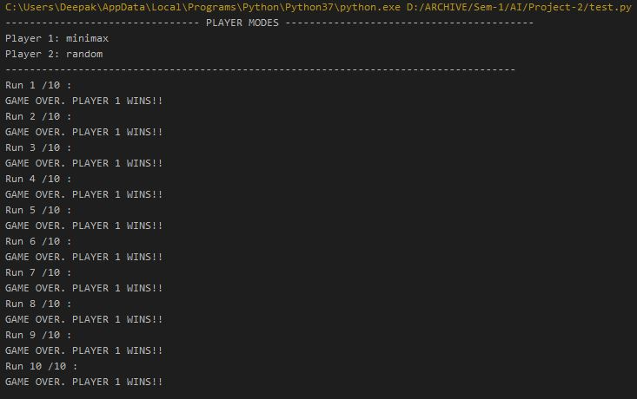

Minimax(depth of 6) vs Human:

There is also a Human-Minimax.txt file in the folder, it shows the result of the Minimax(depth of 6) vs human:

*It was not possible to attach a long screenshot of Human playing minimax, Instead we have copy pasted the gameplay in Human-Minimax.txt file in the folder

Alpha-Beta(Depth of 9) vs Random:

There is also a Random-Alphabeta.txt file in the folder, it shows the result of the Alpha- Beta(Depth of 9) vs Random:

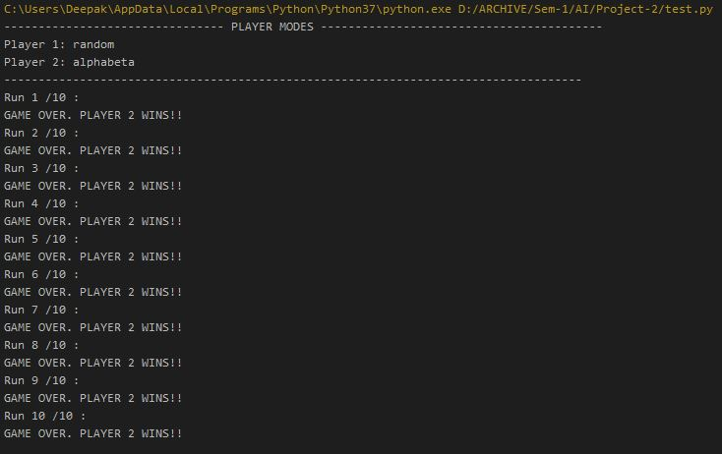

Alpha- Beta(Depth of 9) vs Human:

*It was not possible to attach a long screenshot of Human playing Alpha-Beta, Instead we have copy pasted the gameplay in Human-AlphaBeta.txt file in the folder

|  |  |  |
| --- | --- | --- |
| Win_rates | Minimax | Alpha-Beta |
| Random | 100% | 100% |
| Human | 80% | 100% |

There is also a Alphabeta_human.txt file in the folder, it shows the result of the Alpha- Beta(Depth of 9) vs Human:

Thank You. Please let us know if you need any more details.